Mapping Cardinality

- Student - Guardian (One-to-Many)

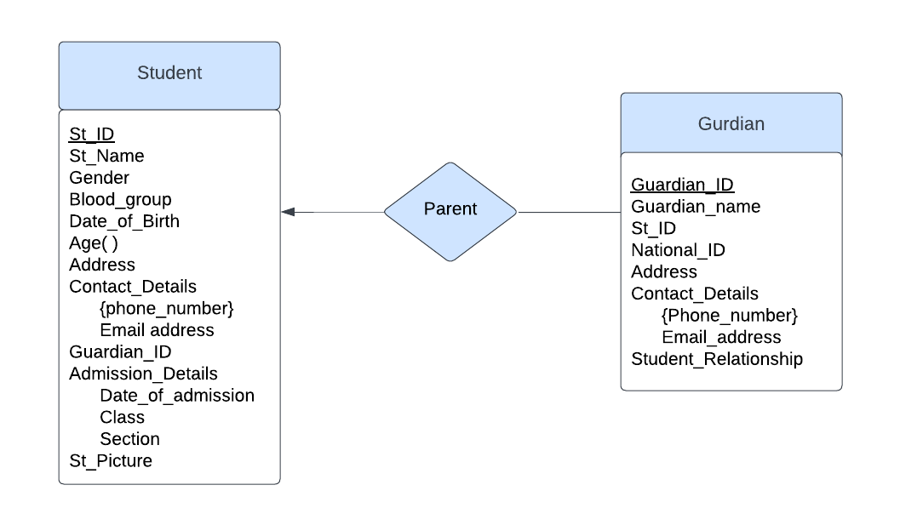
- Teacher - Department (Many-to-Many)

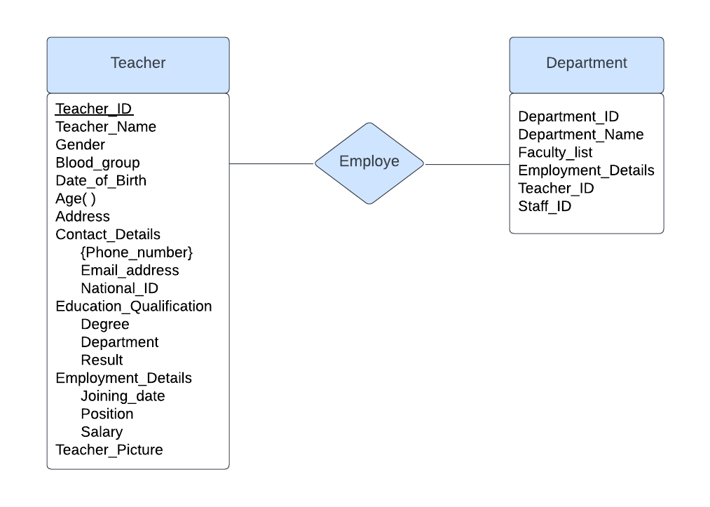

- Teacher - Class (Many-to-Many)

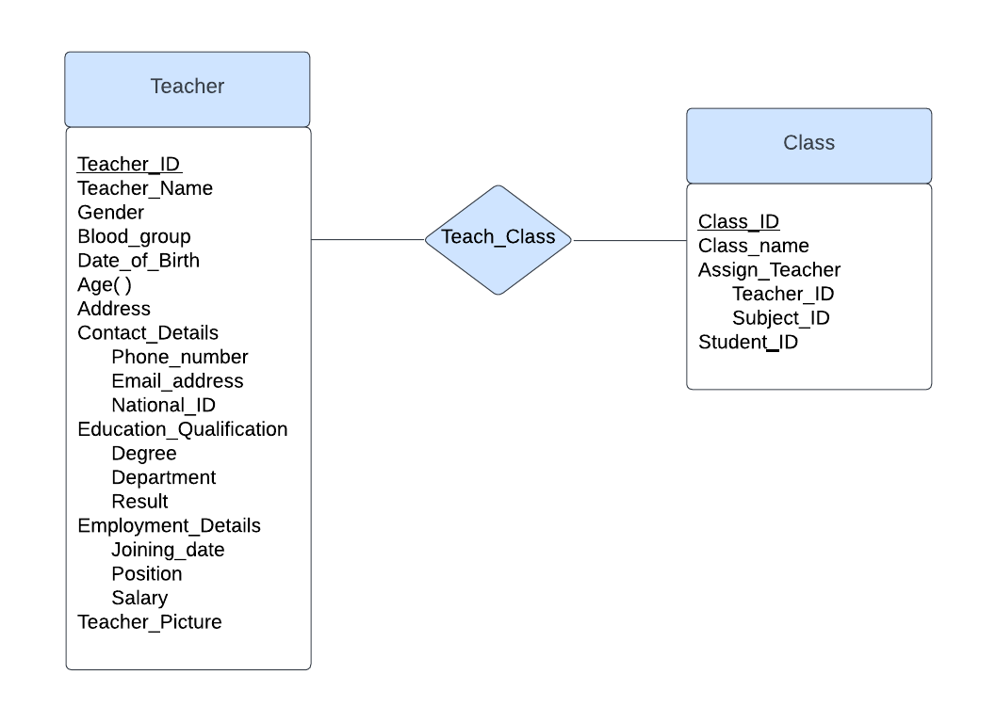

- Student - Class (One-to-Many)

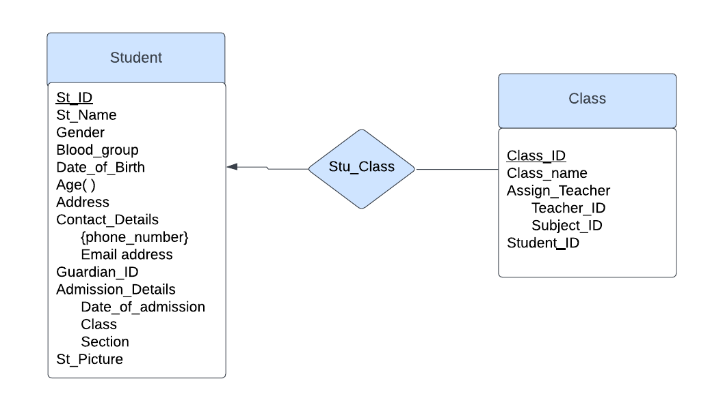

- Staff - Department (Many-to-Many)

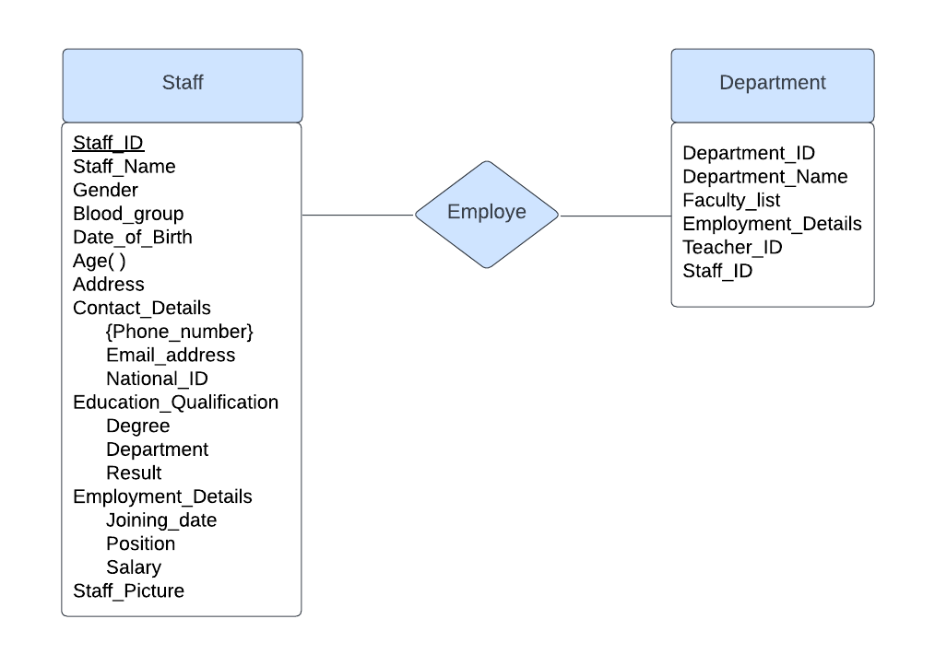
- Department - Subject (One-to-Many)

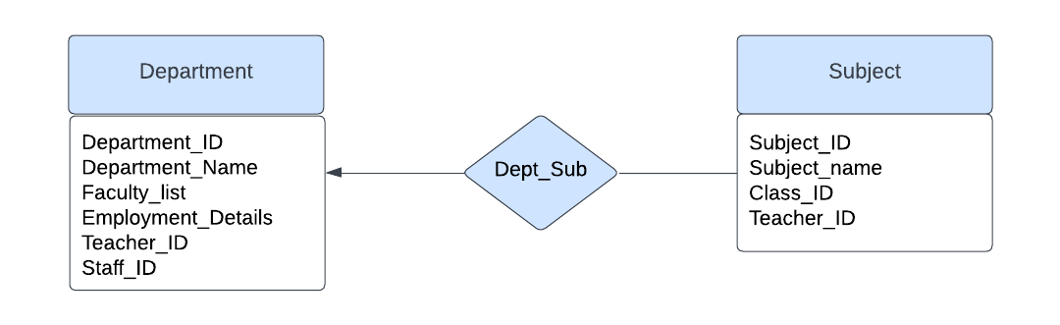

- Exam - Class (Many-to-Many)
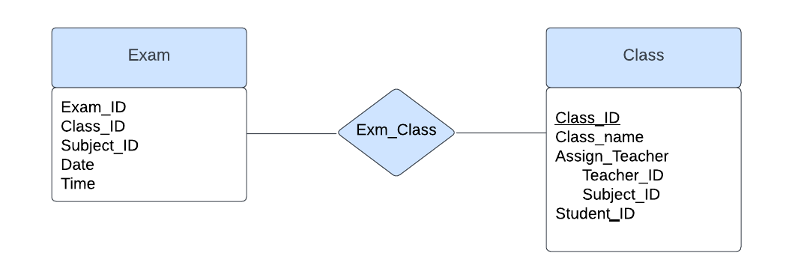
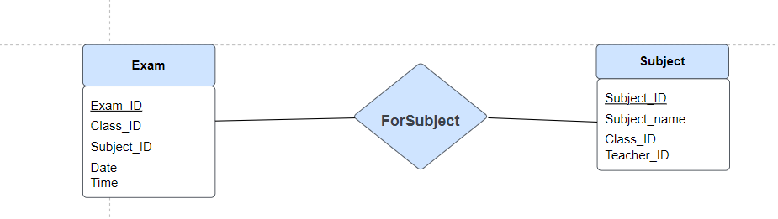
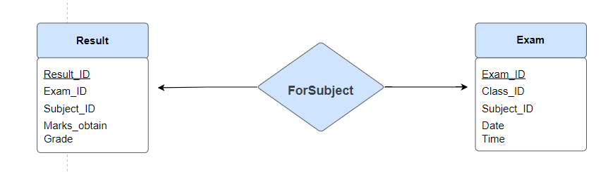
- Exam - Subject (Many-to-Many)
- Result - Exam (One-to-One)

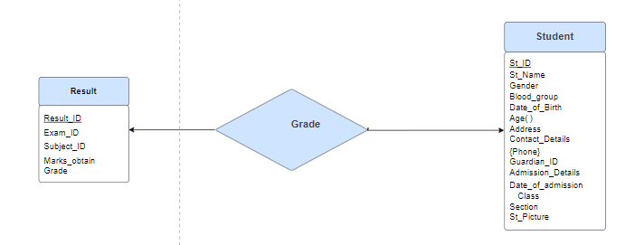
- Result - Student (One-to-One)

- Attendance – Student (Many-to-One)
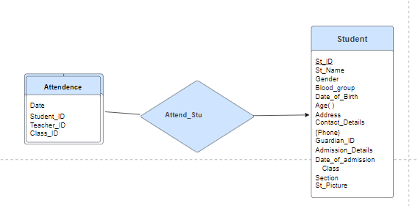
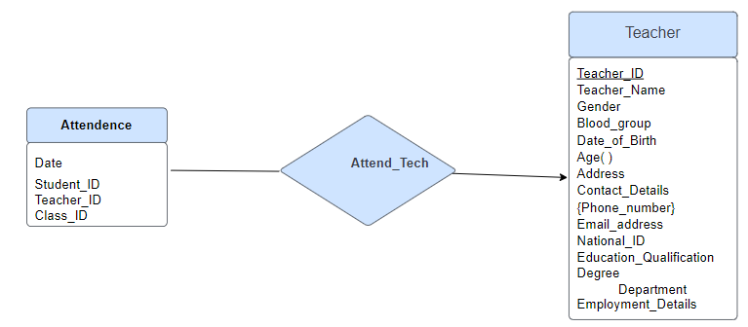
- Attendance – Teacher (Many-to-One)

- Schedule – Student (One-to-Many)
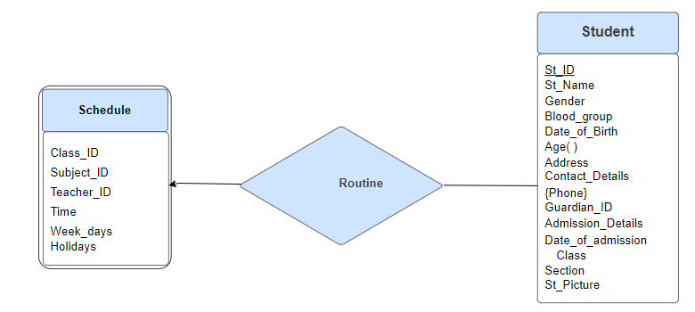

- Schedule – Teacher (One-to-One)
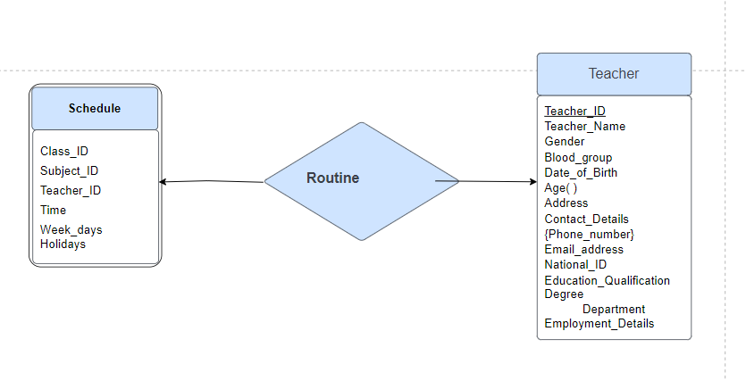
- Accounting - Guardian (One-to-Many)
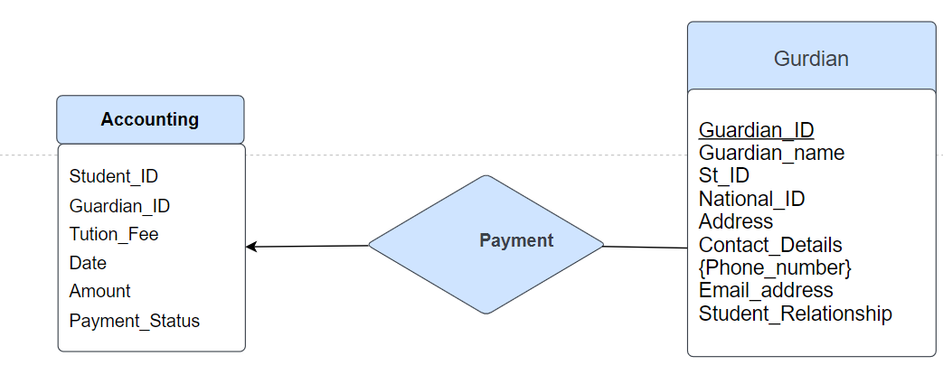
- Accounting - Student (One-to-Many)
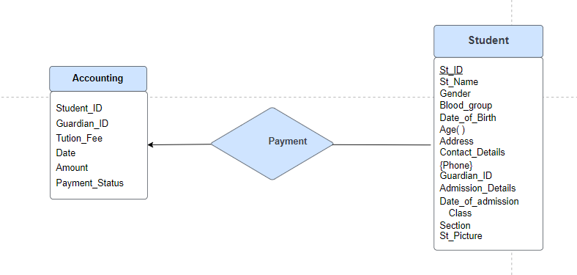

Schema for this.
Department (Department_ID, Department_Name, Faculty_list, Employment_Details, Teacher_ID, Staff_ID)
Teacher (Teacher_ID, Teacher_Name, Gender, Blood_group, Date_of_Birth, Age(), Address, Phone_number, Email_address, National_ID, SSC, HSC, BSc, Department, Result, Joining_date, Position, Salary, Teacher_Picture)
Subject (Subject_ID, Subject_name, Class_ID, Teacher_ID)
Class (Class_ID, Class_name, Assign_Teacher, Teacher_ID, Subject_ID)
Exam (Exam_ID, Class_ID, Subject_ID, Date, Time)
Result (Result_ID, Exam_ID, Subject_ID, Marks_obtain, Grade, GPA)
Attendance (Date, Student_ID, Teacher_ID, Class_ID)
Schedule (Class_ID, Subject_ID, Teacher_ID, Time, Week_days, Holidays)
Accounting (Accountant_ID, Student_ID, Guardian_ID, Tution_Fee, Date, Amount, Payment_Status)
Guardian (Guardian_ID, Guardian_name, St_ID, National_ID, Address, Phone_number, Email_address, Student_Relationship)
Student (St_ID, St_Name, Gender, Blood_group, Date_of_Birth, Age(), Address, Contact_Details, Guardian_ID, Admission_Details, St_Picture)

